PRODUCT RECALL

MOROCCAN TEA GLASS

NOT FOOD SAFE – For Decorative Use Only

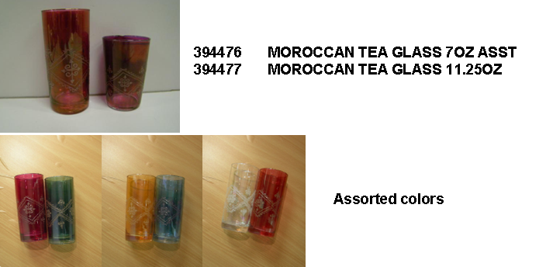

For a full refund, return the glassware to any Cost Plus World Market store.

Call Cost Plus, Inc. for additional information at

1-877-967-5362
7:00 am to 12:00 am EDT

Further details are located at: www.worldmarket.com

