SAFETY RECALL

ALLERGEN ALERT on UNDECLARED SULFITES in the
Orchids Dried Shiitake Mushroom
sold at Cost Plus World Market Stores

The affected lot may pose a potential health hazard to those with sulfite allergies or sensitivities who consume the product.

Package Image front Package Image back LOT # BEST BY NOV.2020
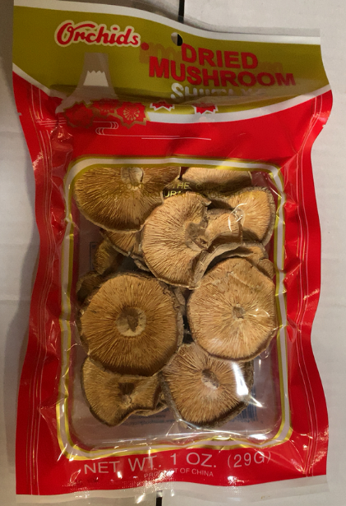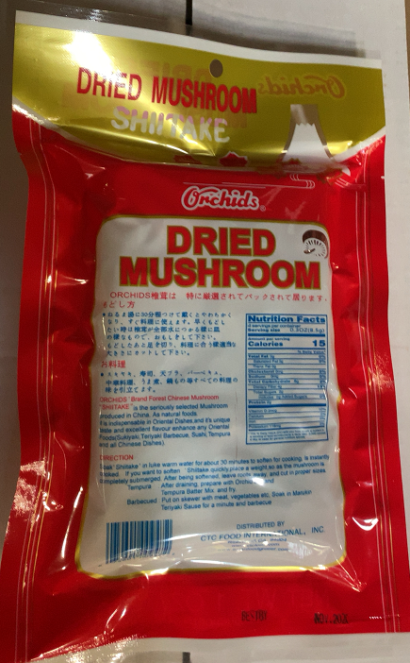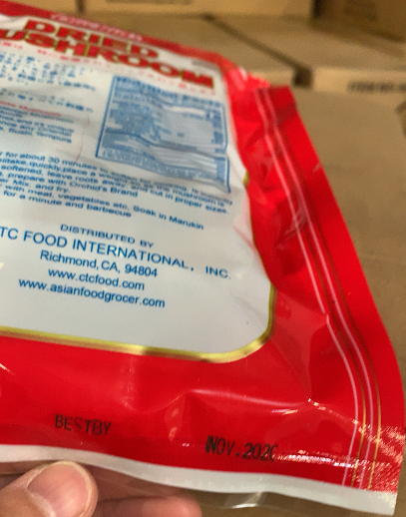

SKU | SKU Description | Affected Production Lot Codes | UPC # | Retail
901210 | ORCHIDS DRIED SHIITAKE MUSHROOM | BEST BY NOV. 2020 | 0-74601-00947 | $2.49

Consumers should immediately stop using the recalled product and return it to
any Cost Plus World Market or World Market store for a refund.

Consumers can contact CTC International, Inc. at (626) 330-1250, Monday – Friday, 8am-4:30pm PST or
email: info@ctcfood.com, for further information about the recall.

Post until 11/16/2019 In cooperation with the Food & Drug Administration

