SAFETY RECALL

Laceration Hazard

Toys/Animal Snap Bracelets
TOYSMITH

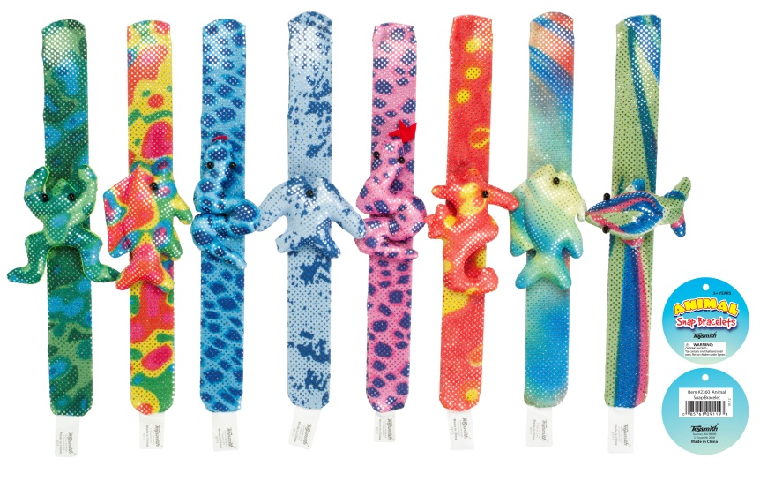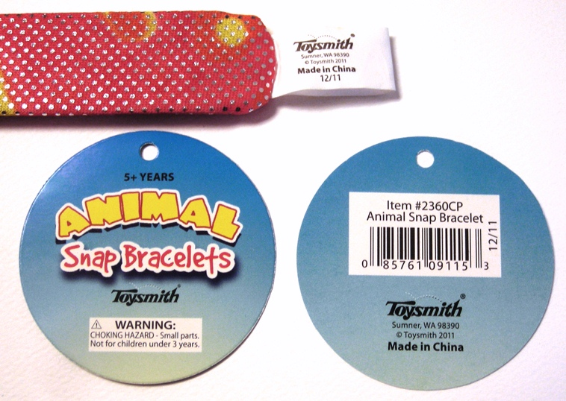

Item number: 2360CP / CPWM SKU: 430638
UPC Code: 0 85761 09115 3
Date Codes (can be found on sewn-in tag): 07/11, 08/11, 11/11

Consumers should immediately take away the recalled Animal Snap Bracelet from children. For a full refund take the Animal Snap Bracelet to any Cost Plus World Market Store.
Call Toysmith for additional information at:
1-800-356-0474
8:00 am to 5:00 pm PT
Further details are located at: www.toysmith.com

In cooperation with Toysmith and the U. S. Consumer Product Safety Commission

